**Name: Bhupinder**

**ID: 3157552**

**Title: Court Cases**

**Task 1 - Identify the problem**

**Call Discussion with Client: Inderjit**

**Information of the client:** Inderjit, a lawyer by profession, called me for an application; to make his work easy and simplified. As he has to attend the court hearings and even has to meet his clients, manual things are getting messed up. So he wants a proper software for it.

**Primary objective of the project:** The thing to be kept in mind while making this software is that the things at utmost priority are to be first. The court hearings are very important and can't be skipped at any cost, so a proper hour to hour schedule is being made by the software to arrange the day accordingly. He can even fill in the appointments in between the hearings or whenever he has time for them. The software will help him schedule his day/week/month accordingly.

**Task 2 - Define and document requirements**

Requirement of The Software

Scope of Work

**Features:** Handling the court cases has become a mess for Inderjit. He wanted to have a smooth and simple software for managing his day to day court cases, appointments etc. As he is having a hectic schedule all over the week with judges, cases and clients. To streamline his work, he needs the software.

**Functional Requirements:** The modules covered in this software should have a list of various judges and it should be updated along with whether the judge deals with the criminal or civil cases. Also software should be able to provide the list of all of his hearings he is having with various judges in a day, along with the brief of each case and it's hearing orders from the last hearing. The software should be capable of maintaining the records of the court room too, where will be the next hearing etc. He also needs to have a list of lawyers along with their specialities. He needs to have information of his clients too, and to maintain their records and data, he needs to have simple yet accurate software.

**Non-functional requirements:** The software should be able to identify the tasks that are important, and are able to prompt that first, where attention is much needed. Also clients may need to see their hearing orders for their hearings, they can access the software with proper Authorization, to get their orders on their cases. For organizing his day, he needs the software, as he can plan his day accordingly.

Time: It will take minimum 20 days to complete. Which is showing under below:

|  |  |
| --- | --- |
| Study | 5 |
| Requirement Gathering | 3 |
| Designing | 2 |
| Development | 8 |
| Testing and Implementation | 2 |

**The 4 essential steps of the Risk Management Process are:**

1. **Identify the risk:** Being able to identify what types of risk you have is vital to the risk management process.
2. **Measure frequency and severity :** This will help you identify which are very unlikely or would have low impact, and which are very likely and would have a significant impact.
3. **Treat the risk:** Find the needed resources, such as personnel and funding, and get the necessary buy-in. Senior management will likely have to approve the plan, and team members will have to be informed and trained if necessary.
4. **Monitor and Report on the risk:** Risk management is a process, not a project that can be “finished” and then forgotten about. The organization, its environment, and its risks are constantly changing, so the process should be consistently revisited.

**Cost:** Project would be costed on $550.

|  |  |
| --- | --- |
| Study | $50 |
| Requirement Gathering | $50 |
| Designing | $150 |
| Development | $150 |
| Testing and Implementation | $150 |

**Project Management**: here are a few essential questions that are worth to answer during measuring your project success. For a greater understanding of the topic, we will use here the examples connected with the type of projects that we have the greatest knowledge about. And that’s web & mobile app development.

**Gantt Chart:**

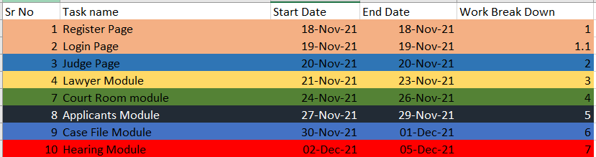

**Task 3 - Design mockups**

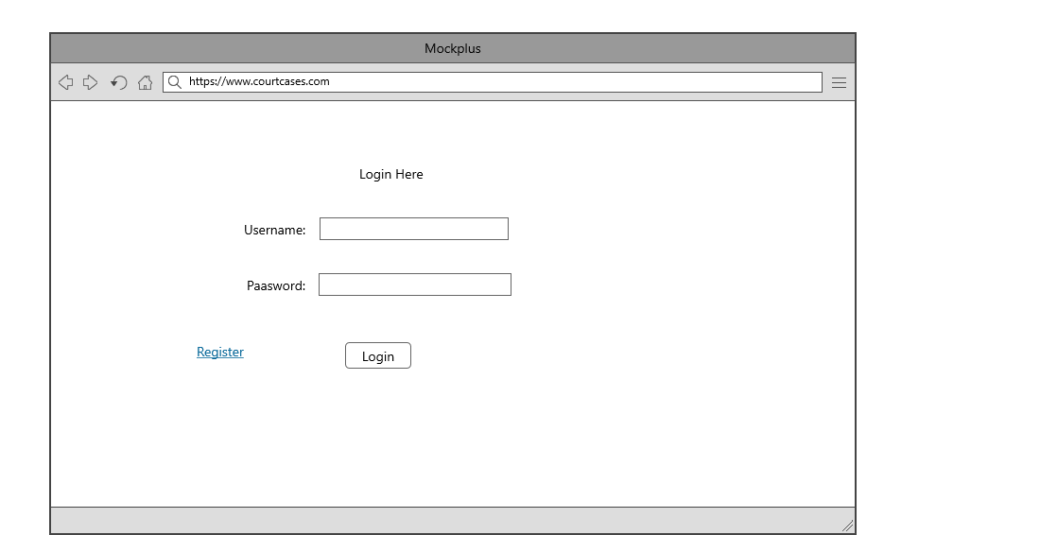

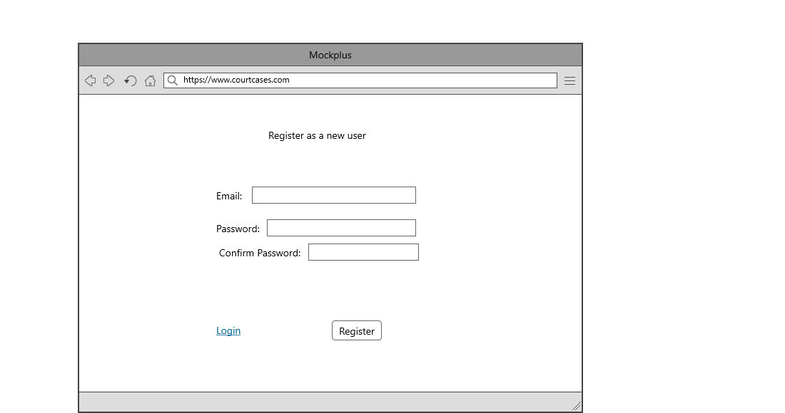

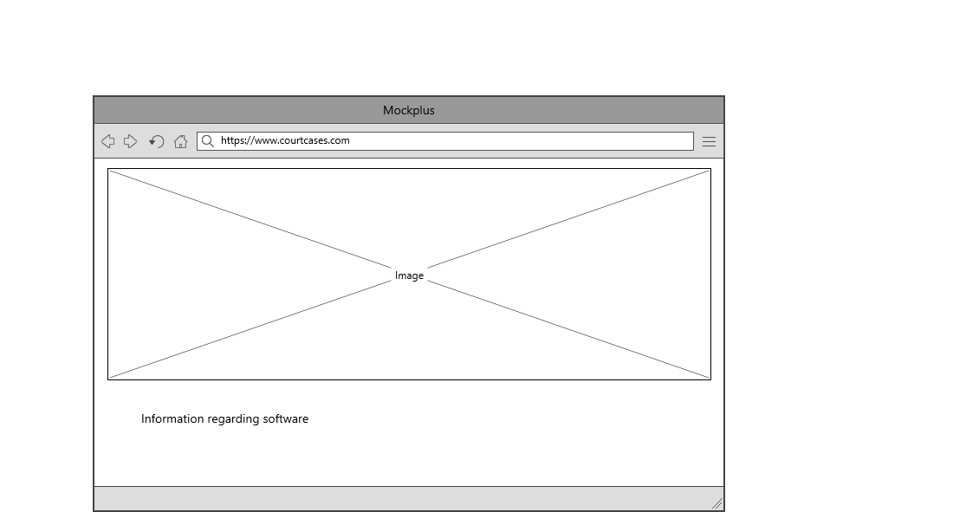

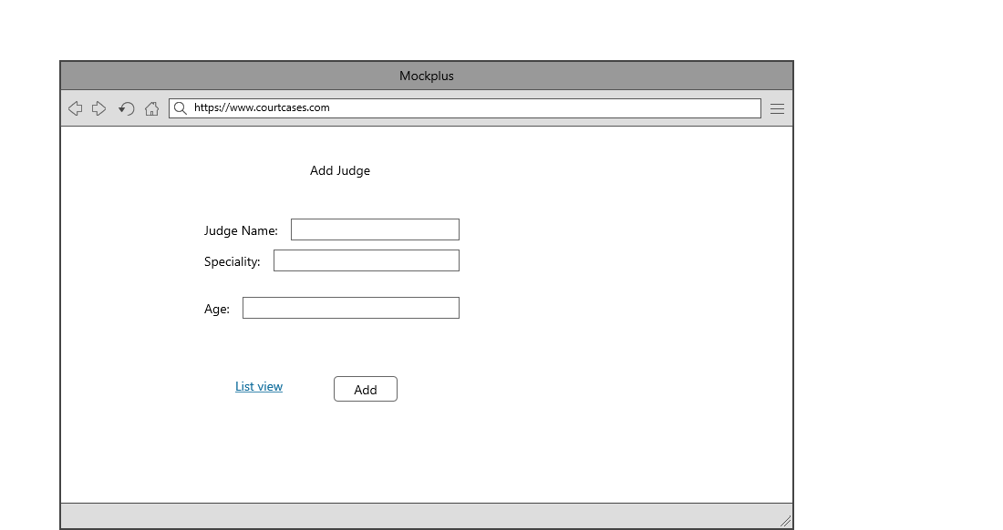

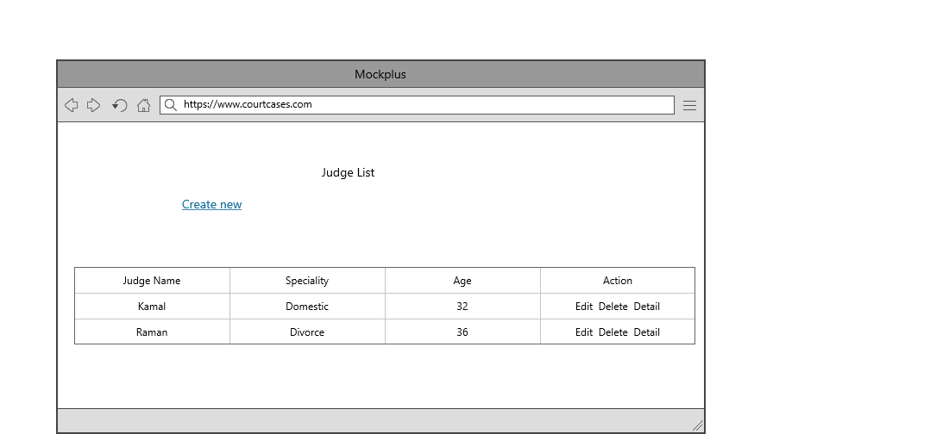

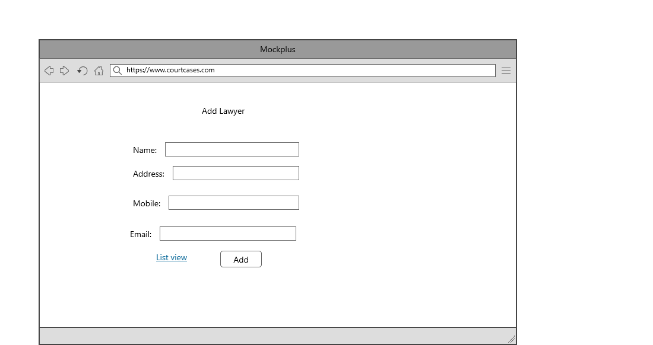

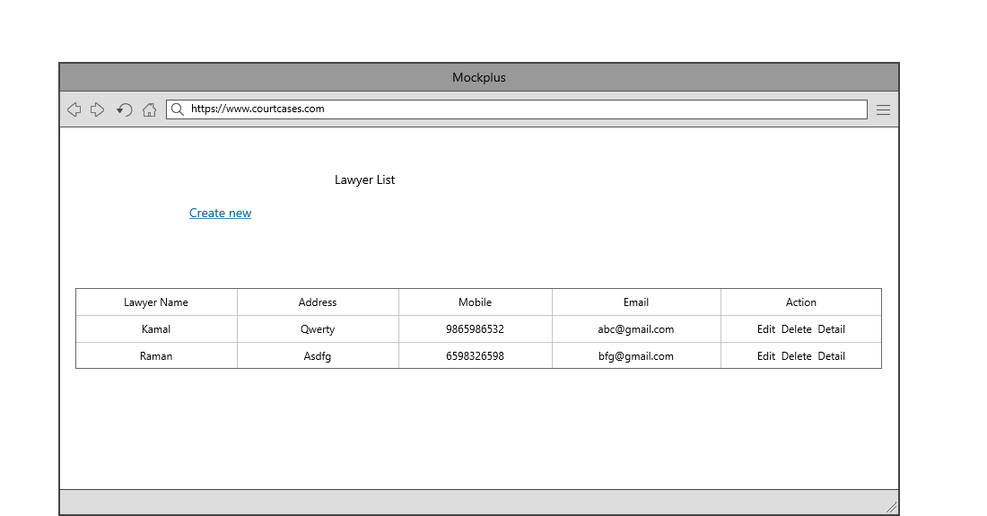

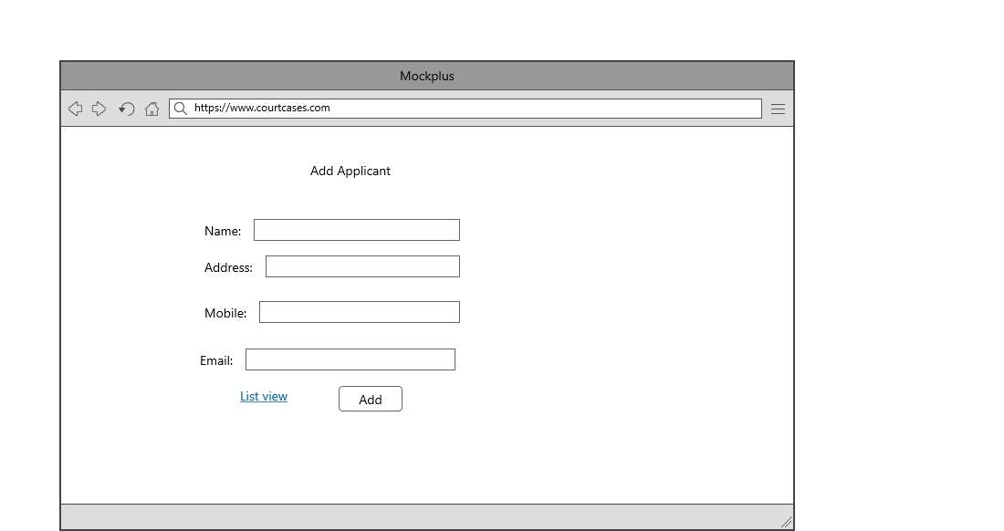

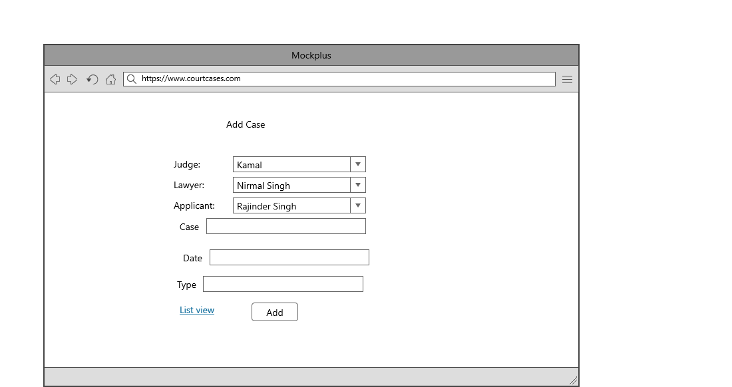

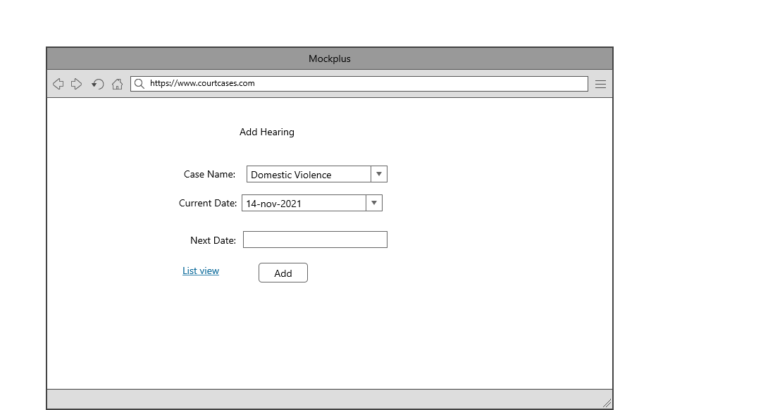

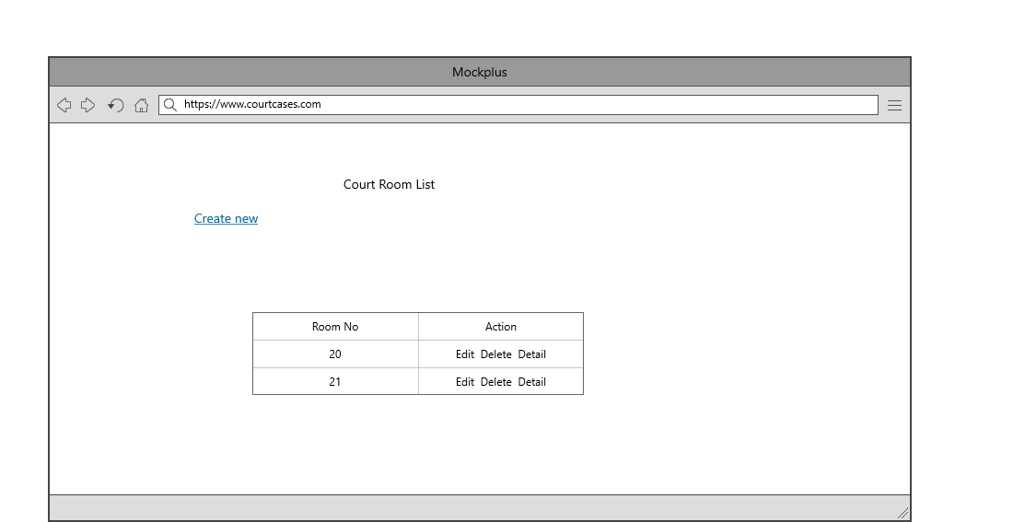

Colour Scheme:

Login and register page: Background image.

Menu Bar: Black, white and yellow combination.

Body: background images.

Table and forms: Black and white.

## Task 5- usability testing

|  |  |  |  |  |  |
| --- | --- | --- | --- | --- | --- |
| **User #** | **Login form** | **Register form** | **Hearing Module** | **Pass / Fail / Not executed / Suspended** | **Reviews** |
| Inderjit | completed as expected | Page is good | As Expected perfect | Pass | All modules are ok |
| Ram | should some changes and expand more | This page is working in proper way. | might be more attractive | Pass | Login form should be more attractive |
| Rajan | looking good | This page is looking nice | Working according which requirement we have given | Pass | all modules are as expected |

**Task 6 - Meet with your client**

Client Meeting:

|  |
| --- |
| Meeting Details |
| * Date and time: 26-Oct-2021 * Location: Newzealand |
| Attendees: Bhupinder and Inderjit |
| Agenda: Discussion of Software of Court cases system |
| Discussion (Important Points): Written on this document sheet regarding the requirements of the software. |
| My To Dos (Actions): Firstly I have to make the mockups of the application. Then Starting the application after the next meeting. |
| Questions requiring Follow- Up: Discussion of the mock ups |
| Comments: Inderjit is good person and he described regarding software very wisely. |
| Next meeting  Date and Time: 1- Nov-2021 1:00 Pm  Location: Newzealand  Agenda: Showing the mock ups to the client and discussion about further development. |

**Appendix 3**

**Client Review Form**

My developer’s name: Bhupinder

This form is intended to let you review the communication skills of your developer for this assignment. Your review will partly count towards their final mark. Do not take into account technical skills.

# Grading scale

You must grade your developer for each item listed in the tables below. 1 being the lowest, 5 the highest.

|  |  |  |  |  |
| --- | --- | --- | --- | --- |
| **1** | **2** | **3** | **4** | **5** |
| Strongly disagree | Disagree | Ok | Agree | Strongly agree |

# Review your developer

|  |  |  |
| --- | --- | --- |
| **Item** | **Grade** | **Comment** |
| Communicated clearly and effectively | 2 |  |
| Kept you informed of the progress | 5 |  |
| Met timelines | 4 |  |
| Responded promptly to problems | 3 |  |
| Met overall project objectives | 1 |  |
| Was open to new ideas and suggestions | 5 |  |
| Was easy to work with | 5 |  |

Comments

Provide any extra comments on your developer’s communication skills and professionalism.

Bhupinder is good developer. He is very good in his work. I proud to get my work completed by jatin.

## Signed by Client

|  |  |
| --- | --- |
| **Signature: Inderjit** | **Date: 13-nov-2021** |
| **Name: Inderjit** | **Title:Court Cases** |
| **Contact details (email/Tel):** | |

**Task 7- Presentation**

[**video1528021939.mp4**](video1528021939.mp4)

**Task 8 - Software development life cycle stages**

**Planning :-** The purpose of the Planning Phase is to plan all project processes and activities required to ensure project success and to create a comprehensive set of plans, known as the PMP, to manage the project from this phase until project termination.

**Requirement :-** he Software Development Life Cycle begins with requirement analysis phase, where the stakeholders discuss the requirements of the software that needs to be developed to achieve a goal. The aim of the requirement analysis phase is to capture the detail of each requirement and to make sure everyone understands the scope of the work and how each requirement is going to be fulfilled.

**Software Design and prototyping :-** In this phase, the requirement gathered in the SRS document is used as an input and software architecture that is used for implementing system development is derived.

**Output Screens**

**1. Register Page: -** This is Register page in which You can register new user

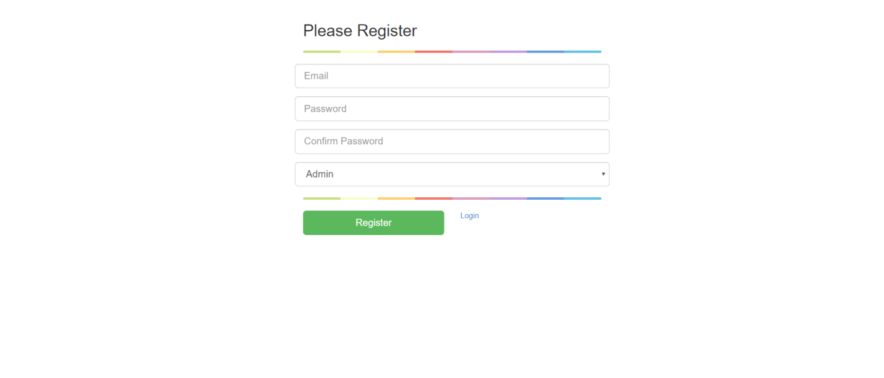

**2. Login Page: -** This is Login page of our website. In this page I can login as a Admin and As a Manager.

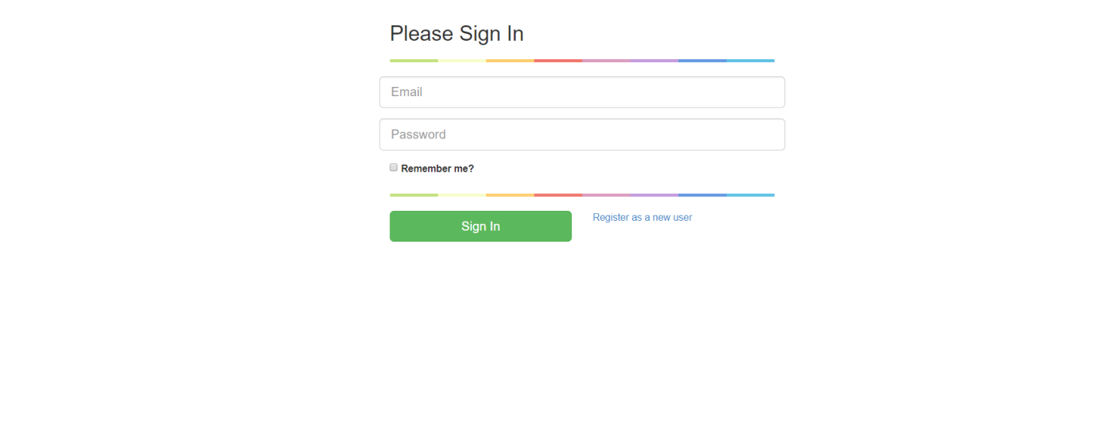

**3. Admin Login**: When admin logins then he can access the all modules of website. Which are shown in the picture.



**4. Judge: -**  Here I can show the judge in my website. And clicking on the create new link I can create the judge. Edit and delete judge are also available here.



**5. Lawyer: -**  Here I can show the lawyer in my website. And clicking on the create new link I can create the lawyer. Edit and delete customer are also available here.



**6. Court Room: -**  Here I can show the court room in my website. And clicking on the create new link I can create the court room. Edit and delete court room are also available here.



**7. Applicant -**  Here I can show the applicant in my website. And clicking on the create new link I can create the applicant. Edit and delete applicant are also available here.



**8. Case File: -**  Here I can show the case file in my website. And clicking on the create new link I can create the case file. Edit and delete case file are also available here.

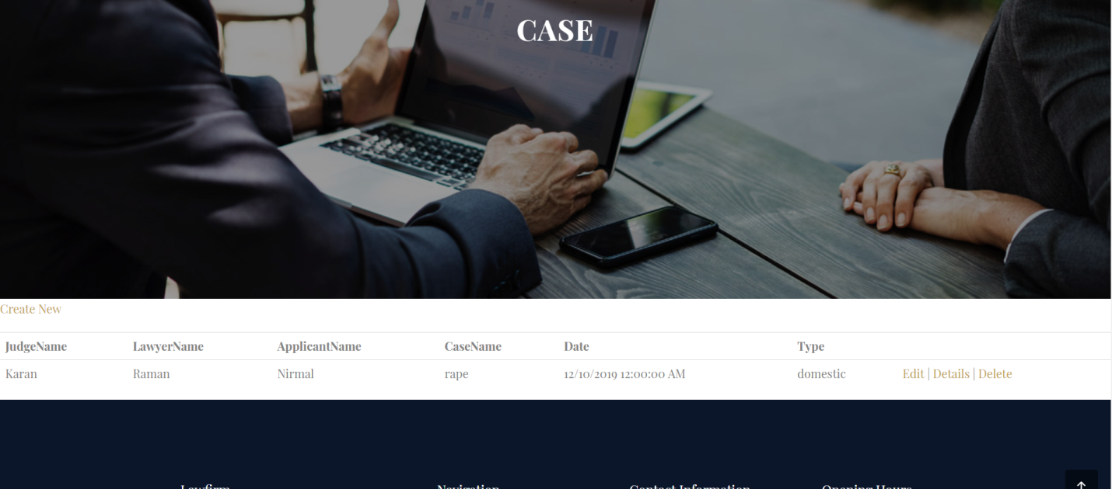

**9. Hearing: -**  Here I can show the hearing in my website. And clicking on the create new link I can create the hearing. Edit and delete hearing are also available here.



**Development:**

After the requirements and design activity is completed, the next phase of the SDLC is the implementation or development of the software. In this phase, developers start coding according to the requirements and the design discussed in previous phases.

Testing:

Testing is the last phase of the software development life cycle before the software is delivered to customers. During testing, experienced testers start to test the system against the requirements.

**Task -9 Project Management:**

Whether you’re in charge of developing a website, designing a car, moving a department to a new facility, updating an information system, or just about any other project (large or small), you’ll go through the same four phases of project management: planning, build-up, implementation, and closeout. Even though the phases have distinct qualities, they overlap.

For example, you’ll typically begin planning with a ballpark budget figure and an estimated completion date. Once you’re in the build-up and implementation phases, you’ll define and begin to execute the details of the project plan. That will give you new information, so you’ll revise your budget and end date—in other words, do more planning—according to your clearer understanding of the big picture.

Planning: How to Map Out a Project

When people think of project planning, their minds tend to jump immediately to scheduling—but you won’t even get to that part until the build-up phase. Planning is really about defining fundamentals: what problem needs solving, who will be involved, and what will be done.

Determine the real problem to solve

Before you begin, take time to pinpoint what issue the project is actually supposed to fix. It’s not always obvious. Say the CIO at your company has asked you, an IT manager, to develop a new database and data entry system. You may be eager to jump right into the project to tackle problems you have struggled with firsthand.